Predictive Modelling of Iris Flower Species using Supervised Learning
Harshil Gupta
B. tech (Computer Engineering with Data Science),
Jss University
Period of Internship: 21st January 2026 – 17th February 2026
Report submitted to: IDEAS – Institute of Data- Engineering, Analytics and Science Foundation, ISI Kolkata

Abstract
This project revolves around the classification of iris flowers using machine learning algorithms, namely Logistic Regression and Random Forest. The Iris dataset contains 150 examples.
The dataset was split into a training set and a testing set to test the performance of the models. Logistic Regression was used as a linear classifier, while Random Forest was used as an ensemble method to increase the accuracy of predictions.
This research proves that machine learning algorithms can be used to efficiently solve multi-class classification tasks and that comparing models is a crucial step in choosing the best algorithm for a particular task.

Introduction
Machine learning has transformed the way data is classified, especially with the advent of supervised classification. This particular project uses the famous Iris dataset—a standard dataset with 150 examples from three different species (Setosa, Versicolor, and Virginica) to test the accuracy of the models. Each example is characterized by four prominent features: sepal length, sepal width, petal length, and petal width.

To solve this multi-class classification problem, we will apply and compare two different algorithmic strategies:

- Logistic Regression: A basic linear algorithm that estimates class probabilities to determine decision boundaries.

- Random Forest: An ensemble learning algorithm that combines the predictions of multiple decision trees to improve accuracy and prevent overfitting.

By comparing these models, this research will examine the complexity trade-offs between linear models and ensemble models. The findings of this study will offer real-world advice on model choice and assessment, demonstrating the impact of mathematical differences on the accuracy of biological data classification.

Project Objective
- To examine the Iris dataset and determine its structure and characteristics.
- To examine the relationship between flower attributes such as sepal length, sepal width, petal length, and petal width.
- To conduct an exploratory data analysis (EDA) on the dataset using statistical techniques.
- To correctly classify iris flowers into three species:
- Setosa
- Versicolor
- Virginica
- To comprehend the use of machine learning in multi-class classification tasks.
- To compare the performance of both models using evaluation metrics such as accuracy score, confusion matrix, and classification report.
Methodology
- Research Design
- The proposed project adopts a quantitative analytical research design. The main aim of this project is to analyze the morphological values of the iris flower and categorize them according to their species.

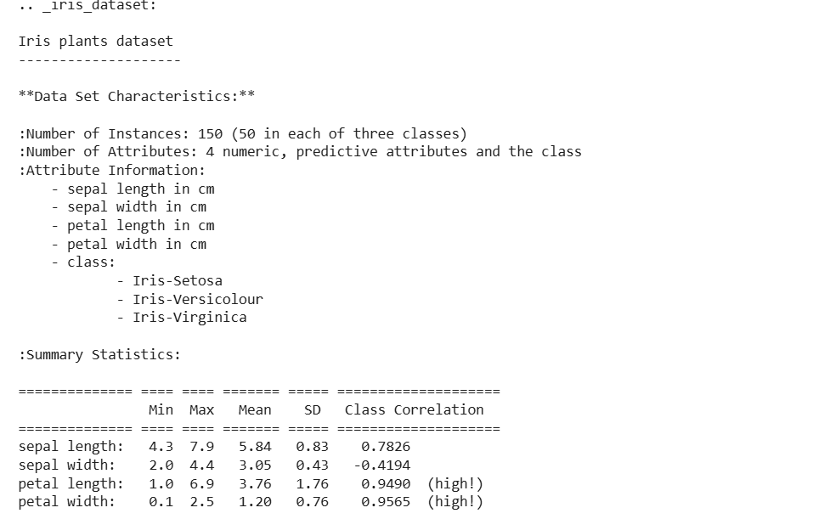
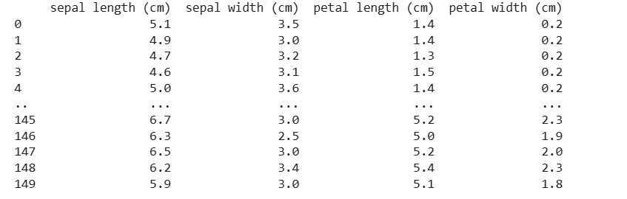

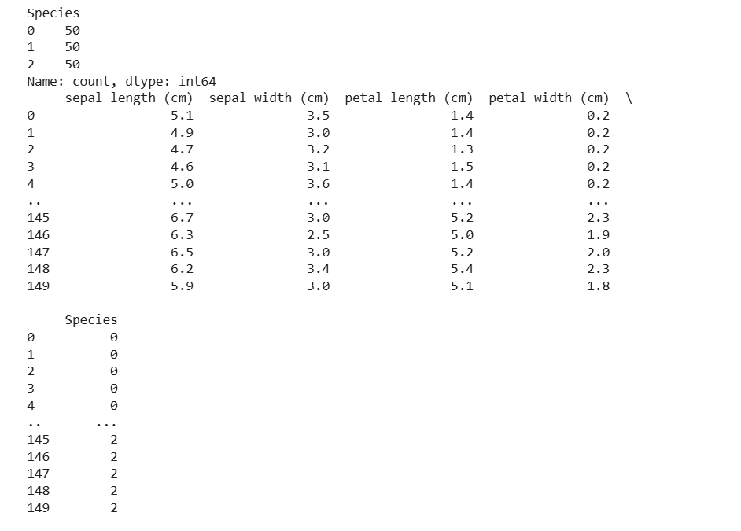
- Data Collection
- The dataset employed for this project is the Iris Flower Dataset, which is in the form of a CSV file (iris_system (2).csv). This dataset has 150 observations and 5 variables, of which four are independent variables or features, and one is the dependent variable or target class.
- Features:
- Sepal Length (cm)
- Sepal Width (cm)
- Petal Length (cm)
- Petal Width (cm)
- Target Variable:
- Species (Setosa, Versicolor, Virginica)
- Tools and Technologies Used
- The following tools were used in the project:
- Python – Programming language used for implementation
- Pandas – Data manipulation and preprocessing
- NumPy – Mathematical and numerical operations
- Matplotlib – Data visualization
- Scikit-learn – Machine learning model development
- Google Colab – Execution and development environment
- Data Preprocessing
- Data preprocessing is a critical step to ensure data quality and model reliability.
- The following steps were performed:
- Verify dataset structure
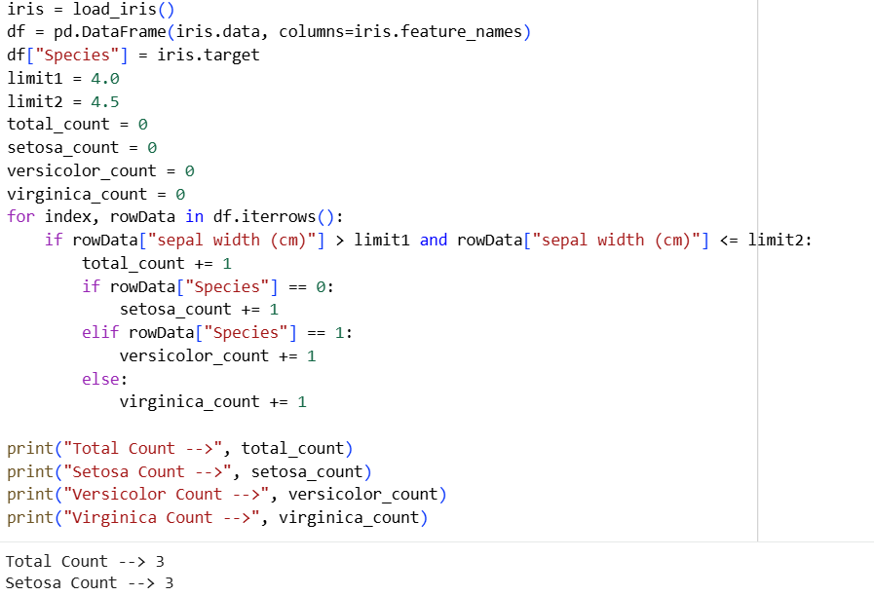

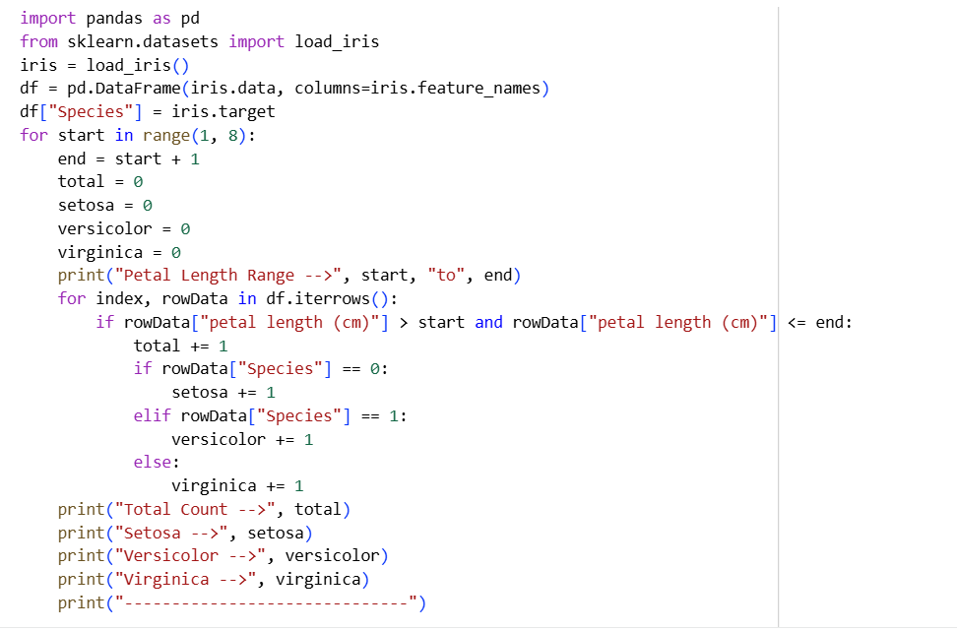
- Checked for missing values
- The dataset contained no missing values.
- Verified data types to ensure numerical features were correctly formatted.
- Confirmed class distribution to ensure balanced dataset
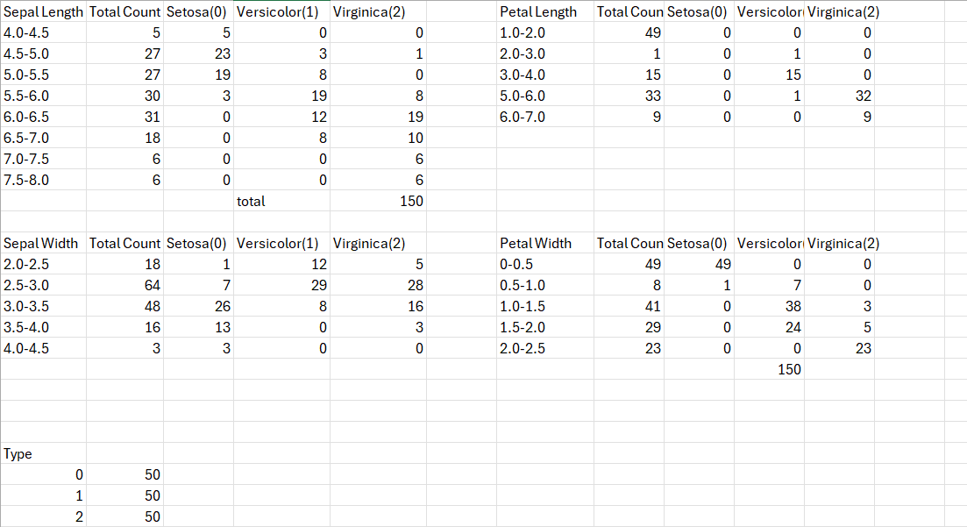
Exploratory Data Analysis (EDA)
  - Exploratory Data Analysis was performed to examine the relationships between the variables and species.
  - Summary statistics using df. describe()
  - The mean, minimum, maximum, and standard deviation of the values were examined.
  - Visual Analysis:
  - Scatter plots of:
  - Petal Length vs Petal Width
  - Sepal Length vs Sepal Width
  - Histograms for feature distribution
Feature Selection
  - All four features were used in model training:
- Sepal Length
- Sepal Width
- Petal Length
- Petal Width
  - Based on analysis, petal-related features contribute more significantly to classification accuracy.
  - Model Development
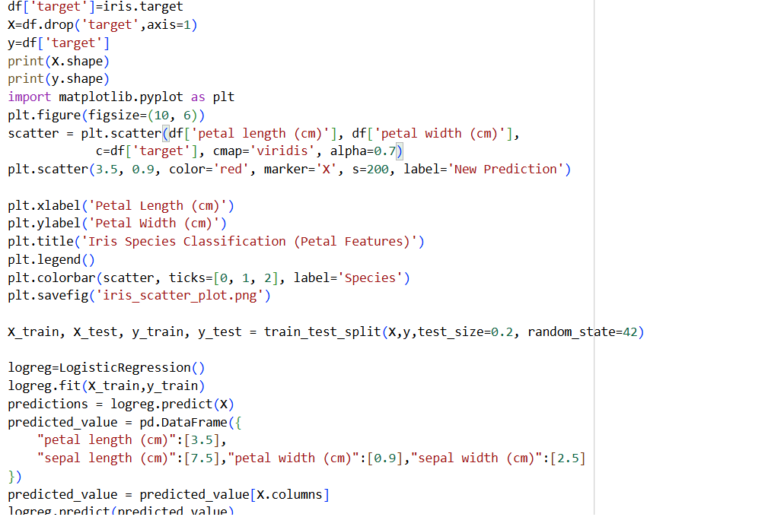

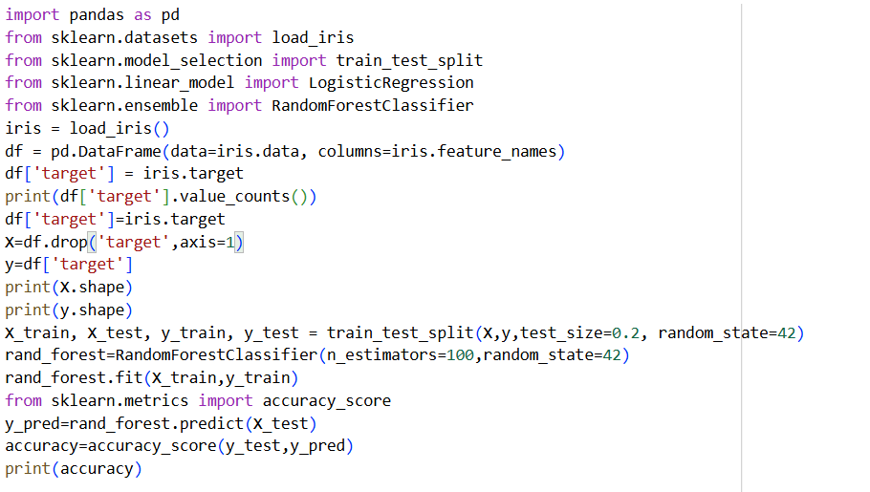

  - Model Evaluation
  - The model performance was evaluated using:
- Accuracy Score
- Confusion Matrix
- Classification Report
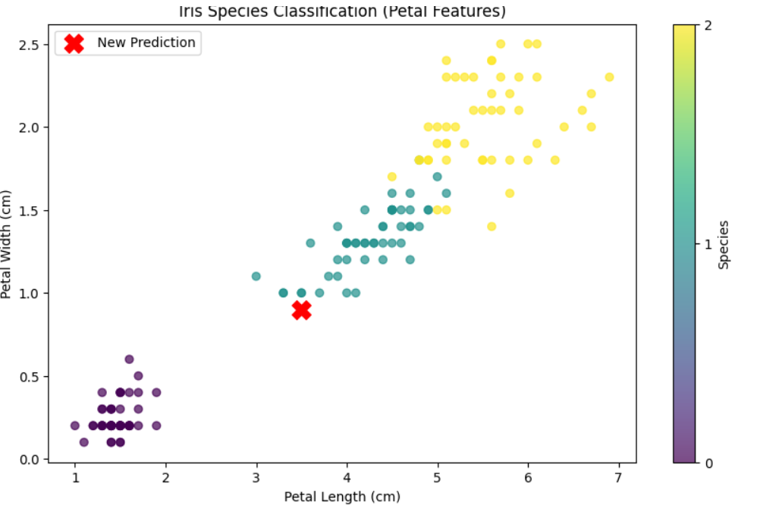

Data Analysis and Results

The Iris dataset was explored using descriptive statistics and data visualizations like scatter plots and histograms. The dataset consists of 150 samples, each equally representing three species of iris: Setosa, Versicolor, and Virginica. Based on the analysis, it was noted that petal length and width are the most distinguishing characteristics, as Setosa is a distinct group, while Versicolor and Virginica are slightly overlapping. However, sepal length and width were more overlapping and less distinguishing. Once the model was trained and tested, it performed very well, with most errors being between Versicolor and Virginica. In conclusion, the data suggests that iris species can be classified with high accuracy based on morphological characteristics, particularly petal length and width.
Conclusion
The Iris Flower Classification project has been able to successfully implement machine learning algorithms to classify iris flowers into different species based on morphological characteristics. By analyzing the data, it has been found that the key factors that determine the classification of Setosa, Versicolor, and Virginica iris flowers are the petal length and width. The data was clean and well-balanced, which contributed to the success of the project. The classification algorithm worked well, and there were hardly any errors in classifying Versicolor and Virginica flowers. The project thus emphasizes the need for exploratory data analysis and feature selection in developing accurate predictive models.
Appendix
1. Wikipedia, Quora, Blogs
2. Survey Questionnaire
Section 1: Biodata Information
- Age: __________
- Gender:
Male
Female
Other
- Height (in cm): __________
- Weight (in kg): __________

Section 2: Medical History
- Have you ever been diagnosed with diabetes?
Yes
No
- Do you have a family history of diabetes?
Yes
No
- Do you suffer from high blood pressure?
Yes
No
- Do you experience frequent urination?
Yes
No
- Do you often feel excessive thirst?
Yes
No
10.Have you experienced unexplained weight loss recently?
Yes
No
3. https://github.com/harshilguptahgs2007-ux/Project_IDEAS_Details_codes1.git

